A0 Time Attendance Management System

Software Manual

Contents
(Ver:1.0)
Chapter One System Function Introduction
Chapter Two Glossary
Chapter Three System Requirements
3.1 Hardware requirements
3.2 Operating environment
Chapter Four Software Installation and the Using Flowchart for the first time
4.1 Installing single-machine edition
4.2 Installing network edition
4.3 Flowchart for the first time use
4.4 Database configure
4.5 System login
4.6 System setting
Chapter Five Software Detailed Operation Instructions
5.1 Personnel information setting
5.1.1 Organization configure
5.1.2 Personnel entry
5.2 Terminal management
5.2.1 Equipment setting
5.2.1.1 Equipment adding and modify
5.2.1.2 Property setting
5.2.1.3 User list Reading
5.2.1.4 Authority canceling
5.2.1.5 Fingerprint and record deleting
5.2.2 Personnel registration
5.2.3 Data gathering (terminal record gathering)
5.3 Time attendance management
5.3.1 Time attendance system setting
5.3.2 Editing attendance time
5.3.3 Special time attendance registration
5.3.4 Time attendance processing
5.4 Access control management
5.4.1 Equipment location setting
5.4.2 Clock in/out detailed query
5.5 Report form printing
5.5.1 Clock in/out list
5.5.2 Daily clock in/out list
5.5.3 Exceptional clock in/out list
5.5.4 Daily time attendance list
5.5.5 Monthly attendance statistics
5.5.6 Daily attendance symbolic list
5.6 System maintenance
5.6.1 Changing your password
5.6.2 Operator management
5.6.3 Data maintenance
5.6.3.1 Data backup
5.6.3.2 Data recovery
5.6.3.3 Data cleaning
5.6.3.4 System initializing
5.6.4 Operating log query
Chapter Six FAQs

Chapter One System Function Instruction

Oriented by user requirements, A0 Fingerprint Time Attendance Management System is a general-purpose fingerprint time attendance management system developed to address the computer management on time attendance of various factories and companies.
A0 Fingerprint Time Attendance System supports two kinds of attendance ways: according to work shift or unfixed work shift. It applies to the company which just has one work shift or has no order (only need to clock in/out with daily attendance).Its no need to arrange the work shift for personnel, convenient operation and supply online service.
This system was characterized by quick and brief analyzing，processing，querying and collecting. The report forms are various as original clock in/out list, exceptional clock in/out list, daily time attendance list, monthly time attendance list, access control clock in/out list and daily time attendance symbolic list. Besides, it is useful to gathering all kinds of data, such as the time attendance, absent time, overtime working, overdue, leave early, both the time and the degree, and various leaves (private affair leave, illness leave, marriage leave etc.) showing with an intuitional symbolic form.
The permission of A0 Fingerprint Time Attendance Management System is set by persons in charge and operators can define their own passwords, which effectively prevents illegal and unauthorized use of the system. The system has strict data input fault tolerance system to prevent wrong operation and illegal data input. Backup function of the system ensures that data will not be lost and the system will restore running quickly when malfunction occurs.
A0 Fingerprint Time Attendance Management System possesses seven major functional modules, namely personnel information setting, terminal administration, time attendance registration, access control management, report form printing, system maintenance and help.

Chapter Two Glossary

1. Terminal
Also named equipment, is the time attendance terminal which is used to clock in/out. It can identify the registered card and registration personnel, memory the clock in/out information, and transmit the data to computer by the 232/485 communication way.
2. Equipment Number
Namely the number of each equipment, which are used to ensure the relative equipments. Make sure that it can not be repeated online.
3. Serial port
Output port of the computer, which is used to the communication between computer and equipment.
4. Baud rate
The transmission speed. Here it means the transmission speed of computer and equipment. Some hardware only supports the fixed baud rate, namely the default baud rate in searching.
5. Editing attendance time
Input personnel’s attendance time by hand.
6. Registration
Write the personnel information, including fingerprint registered number and name on the relative equipment. It reveals the relative number and name when the personnel put his finger on it. Also the clock in/out time will be recorded automatically.
7. Time attendance
It means come and leave office due to the setting time. Namely the actual working time.
8. Absence
It means late attendance, early leave; business trip and outgoing trip overstep the regulate attendance time or it sets to have time attendance both on-duty and off-duty, but just miss one.
9. Time attendance processing
Counting everyone’s attendance result due to the attendance rules, working shift, holiday, general holiday and the clock in/out record, special attendance that the system setting. The result like attendance, overtime working, late, leave early, absent, leave etc. which can be checked after the attendance processing.
10. Work shift
It means the daily working time of the personnel.
11. Work interval
It means the time interval of the work shift, e.g. 08:00-12:00, 13:30-17:30; it is one work shift which contains two work intervals, 08:00-12:00 and 13:30-17:30.
12. Unfixed work shift time attendances
This kind of work shift is use to those personnel whose working time is changeable.
About the detailed contents please read the latter section 4.6
13. Click
Press the left key of the mouse one time; double click: press the left key two times continuously.
14. Clock in/out list
It shows the original clock in/out situation of the personnel according to person, date and time and each record was shown in a single line.
15. Daily clock in/out list
It shows the time of daily clock in/out for everyone and one day’s record was shown in a single line.
16. Exceptional clock in/out list
It shows the exceptional clock in/out situation after the normal clock in/out, including late, leave early, absent, out of work etc.
17. Daily attendance list
It shows the daily attendance of the personnel in working day. It contains the clock in/out time on and off duty, day work and night work(namely actual work time), peacetime overtime, general holiday overtime, holiday overtime, late/leave early times and time, and all leaves( private affair leave, illness leave, marriage leave etc.), time for business etc.
18. Monthly attendance list
It shows the general attendance situation of the personnel within the date range, such as day work and night work, peacetime overtime, general holiday overtime, holiday overtime, late/leave early times and time, and the general time of all leaves and business.

Chapter Three System Requirements

3.1 Hardware requirements:
1. CPU: 1GMHz or higher
2. Memory: 128MB or higher
3. Hard disk: 2GB or higher available hard disk space
4. One communication port (COM port)
(If USB interface is applicable, a USB-COM conversion cable is required)
3.2 Operating environment
1. Single machine operation
Database: MSDE 2000
Operating system: WIN98/2000/ME/XP/NT/2003
2. Network operation
Database: MS SQL SERVER 2000 or higher, enterprise edition/standard edition
Operating system of workstation: WIN98/2000/ME/XP/NT/
Operating system of server: WINDOW NT/2000/2003 SERVER

Chapter Four Software Installation and the Using
Flowchart for the first time

4.1 Installing single-machine edition
1, Put the CD into CD-ROM. Files in the setup package are divided into two parts: Setup package for A0 Time Attendance Management System and MSDE (Microsoft sql Server Desktop Engine).
2, Open the CD content, run Setup.exe and start installing the system
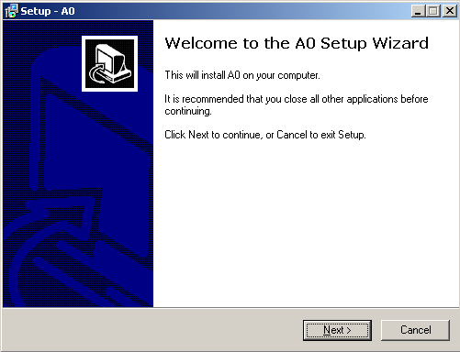

3, Click “Next”, then choose the processing installation path.
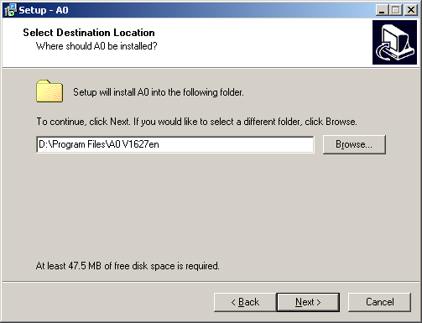
5, Click "Next", then click the “Installation” to install process. After the installation
click the “finish”.
6, Then it will pop-up a dialog box automatically like “ attendance management system requires data-base, whether to install MSDE data-base management system”, click “yes” start to installing MSDE.
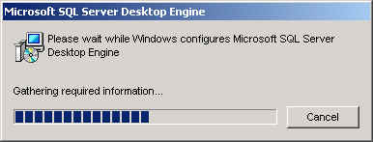
7, After MSDE installation finished, icon of A0 Time Attendance Management System will appear on desktop.
★ Note:
1. Do not run A0 Time Attendance Management System without installing MSDE or other editions of Sql Server.
2, If any edition of Microsoft Sql Server 2000 has been installed on user's computer, MSDE is not required to be installed and only A1 Time Attendance Management Application is required to be installed.
3, MSDE is the free desktop database provided by Microsoft, which can be downloaded by user.
(Note: In such situation, you need to amend the setup.ini configuration files under the setup content. In this file [Options]
SAPWD=sa
SECURITYMODE=SQL
Thereinto, SPAWD means the code of sa accounts after installation, SECURITYMODE means validate mode.)
4.2 Installing network edition
For the online users, you need to install Microsoft SQL Server Standard Edition or Enterprise Edition and A0 attendance management system. The following are the installation steps:
1. Insert Microsoft SQL Server 2000 CD-ROM into the CD-ROM driver.
2. Select "Install SQL Server 2000 components" in the Auto-Run window.
3. Click "Install database server".
4. Select the local computer, then click "Next".
5. Select “Set-up new SQL Server or install client tools”. Click "Next".
6. Fill in user name and company name, and then click "Next".
7. Select "Server and client tools" and then click "Next".
8. Select "Default" single option box and click "Next”. When default is in grey, it means SQL Server has already exist, you can input other instance name and click “Next”.
9. Normal users please select “Typical” single option box, and then click "Next".
10. Select "Use local system accounts" and "Use same accounts for each service.
Auto start SQL Server service (E)." and click "Next".
11. Select "Mixed mode (Windows authentication and SQL Server authentication)". Input "sa" as login password, and click "Next".
12. Click "Next", the operating system will start to copy files and configure SQL server.
13. Click the "Finish" button to complete the installation of Microsoft SQL Server 2000.
- Restart the computer, then install A0 Time Attendance Management System. For specific steps please refer to the installation process for single-machine edition. (Note: No need to install MSDE)

4.3 Flowchart for the first time use

Database
Setting
Login
System setting

Operator Management
Attendance system setting
Equipment setting
Organization setting

Employment
Personnel registration
Data backup

Analyzing the use of flowchart

1, Database setting : After the language setting, it will pop-up the dialog box of database setting, the setting steps are: select server name( Do not need to change the server name if use the local database)—select link mode(the mixed validate of windows and SQL Server is recommended. The default user name and code is sa separately.)—click set up button to establish a new database(use the default database name)—finish, then click confirm button.
2, Login : Then the login window pop-ups ,the initial user name is sa and the code is empty—click confirm to enter the system. Afterwards you can login for dblclick the shortcut key on desktop.
3, System setting: For the initial login, it will prompt for system setting. The user needs to set the company name and logo which will appear on the top of the report form, and select the type of time attendance terminal, namely the terminal number you use.
4, Operator management: If there are several operators to use the system, you should set up an account and code for each operator. Click menu system maintenance—system popedom setting—click add button—input user name and code—save.
5, Time attendance system setting: You can set work shift, late attendance, early leave, overtime, computational rules for attendance, and change his own needed numerical value according to actual circumstance.( the default setting is used for the unnecessary change). Then save it.
6, Equipment setting : Select terminal management—equipment setting—add time attendance terminal—after the adding the user can do other operation. ( It suggests that when use formally, first initialize the equipment to clean the time attendance terminal space. Then set the on-duty time interval, emend equipment time and set the terminal number.)
7, Organization setting: Click the personnel information setting—organization setting—click add—input organization name—save. Complete the adding according to the organization’s hiberarchy.
8, Personnel entry : Click the personnel information setting—personnel entry—input personnel number, name, card number, registered number etc. and set the attendance mode, fix the general holiday.
9, Personnel registration: Click the terminal management—personnel registration—select equipment number(click terminal management—terminal management—click add or amend equipment—successful searching—close the equipment window)—click and select the operator( press SHIFT or CTRL key to select more)—click register button to register the employees in the system and card information into the time attendance terminal.
(Note: This step is different from the fingerprint terminal. When you use the fingerprint terminal, register the fingerprint firstly, then click to read all the fingerprint data.)
10, Data backup: Click system maintenance—data maintenance—data backup—revise code(when the user and code login at the same time)—select save path—click save—finish backup.(Hint: It is suggested to backup database regularly to avoid the system cannot work as the computer trouble. The backup database can be renewed after second installment which can reduce the workload.
4.4 Database configure
After the installation, it will appear the window of database configure for the first operate. This window is used to establish database or connect the existing database, set the connection parameters of the database. The following is the database connection steps:
- Select the database server. The default server is normally used when use the local database. Under the online using, the server name of that service computer on workstation can be selected. After the local database startup successfully, on the lower left corner of the window of database configure, it will show “The local terminal has been startup.
2. Select connecting mode. There are two modes for A0 Time Attendance Program to connect with SQL Server, namely Windows authentication and mixed authentication, and mixed authentication is recommended. If MSDE has been installed as default, both username and password are "sa". If you have installed SQL Server separately, please input corresponding accounts number and password. The default “sa” is recommended.
3. Select database. "Create new database", input the name of the database and click "Create". If database is already existed, directly select "Connect to existing database" for connection, then select the name .
4. After the creation is successful, click "Login into the system" button to access the login window of A0 Time Attendance Management System.

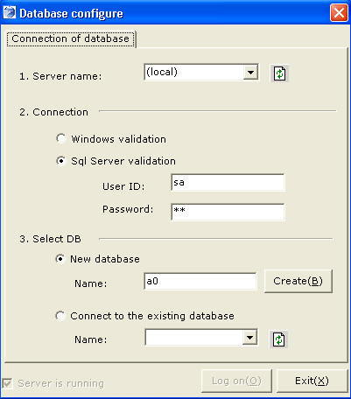

★ Note:
1, (local) means local default instance SQL Server service. If you can not find the specified server: It might be network is disconnected, firewall blocks 1433 port, or the server has not been started. If local server is installed for the first time and SQL Server has not been started, you need to re-startup the computer.
2, If it cannot connect to the specified server, please check whether the authentication mode, user name and password are correct.
3, If the connection to existing database was fail, the database might be damaged.

4.5 System login
The login window is used for verifying the password and commission of the operator currently logging in. The system’s default administrator account is “sa”, and password for initial login is blank.

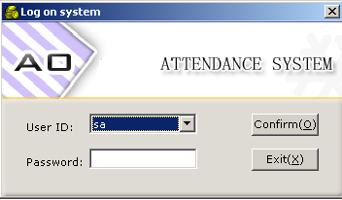
Select the corresponding user, input the password, then click “confirm” button.
4.6 System configure
System configure is used for setting shortened forms of users’ company, company logo, the equipment mode. This window will appear when login for the first time. Or user can open this window via the process of “system maintenance—system configure”.
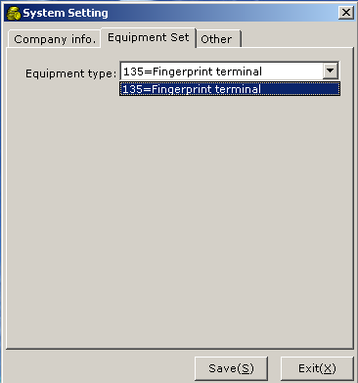

On the interface of user information, input the “company name”, double click the picture box and select the picture of “company logo”, then select the corresponding time attendance equipment type on the interface of time attendance equipment(as the next picture). At last, click the “save” button.
★ Note:
1, “The shortened form of the company”, “company logo” will show on the top of the report form.
2, Different types of terminal have different operation, please make sure the setting is corresponding to the actually used terminal, or else some abnormal faults might be caused. After select the different types of equipment, the equipment operation of the “equipment management” on the main window menu is corresponding to the selected equipment.

Chapter Five Software Detailed Operation Instructions

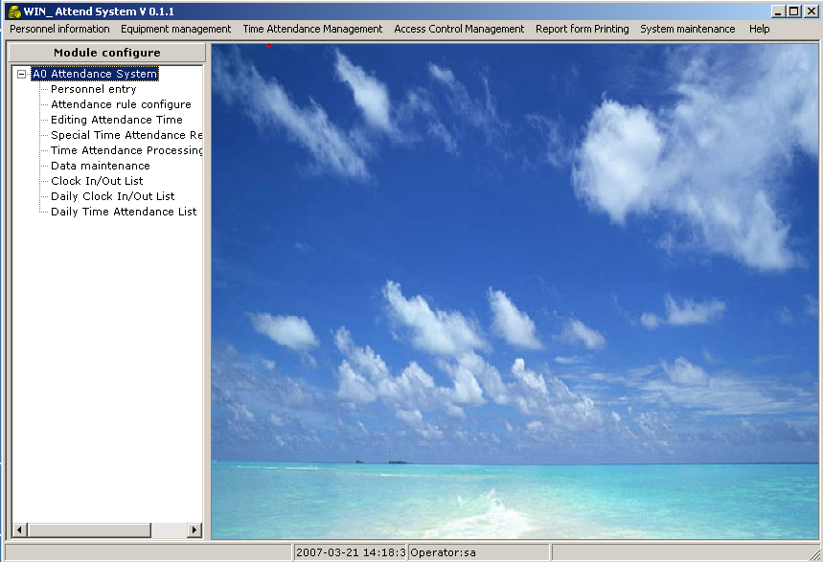
The main interface of system instruction

5.1 Personnel information setting
5.1.1 Organization configure
Organization configure is used for setting company’s organizational structure, including organization number, organization name and remarks, and the hierarchical structure among various organizations can be set. Select the system menu “Personnel information setting －> Organization setting” to access organization setting window. As shown in the following figure.
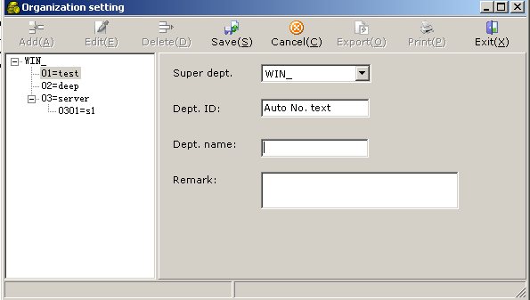
Click , then select super structure, then input “structure name”, click to finish.

5.1.2 Personnel entry
Personnel entry is used for inputting or modifying personnel’s basic information, including personnel information query, import, export, print, job leaver registration etc. Select the system menu “personnel information setting－>personnel entry” to access the window of personnel entry. As shown in the following figure.
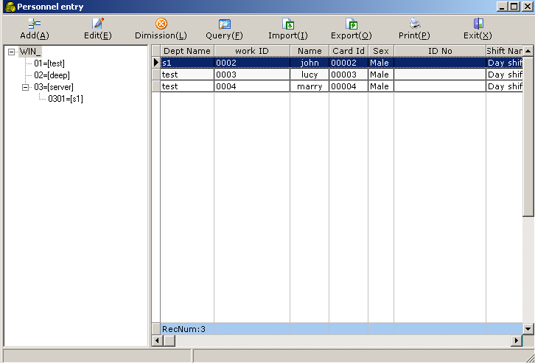
1, Personnel entry: Click “add”, the window of personnel information entry displays, input the corresponding personnel information, click “save” button to finish. If the user wants to rectify personnel’s information, click “edit” button, then click “save” button to finish. Among which the blue font is necessary. As shown in the following figure:
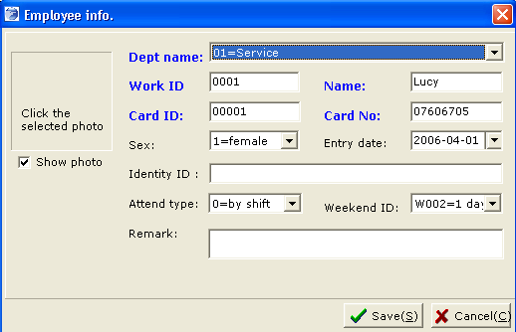
There are two kinds of time attendance modes: time attendance according to work shift and flexible work shift.
A, Time attendance according to work shift: A personnel is on-duty and off-duty according to the rules of time attendance and work shift setting. It is right for the fixed working time.
B, Time attendance flexible work shift: It means the on-duty and off-duty time are ruleless and unfixed, the attendance time was statisticed by clock in/out. In this time attendance mode, the setting value about “how many minutes are recorded for one day” is setting as on-duty time for one day. It is right for personnel whose working time is unfixed.

2, Job leave registration: To operate the job leave registration, click the “job leave” button in the personnel entry toolbar to open the window of job leave registration.
Click ,then click to select job leave personnel. The selecting way is: in the personnel selection window, first, double lclick the departments of the leave personnel on “optional term”, then double click the name of leave personnel on “optional personnel”, more personnel can be selected at one time. The selecting result as shown in the following figure:
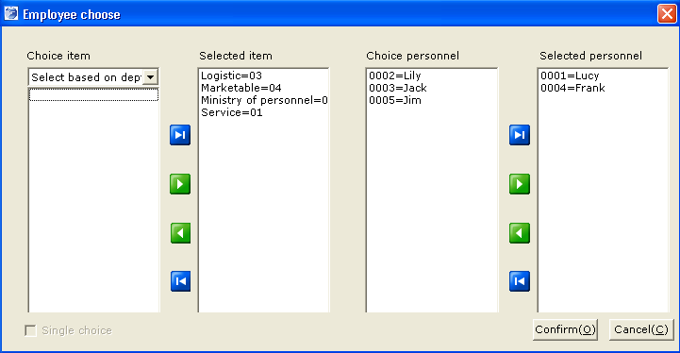

After select the leave personnel, then select the leave date, finally click “save” button to finish.
(Note: After the job leave registration, all information of the job leave employee must be logged out. As shown in the following figure:
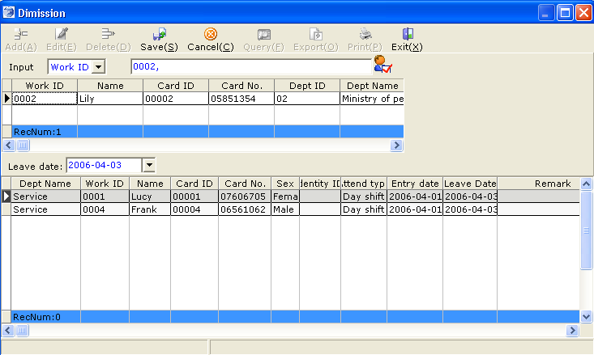

If the job leave employee was employed again or the operator selected the wrong employee by mistake, he can click “job leave renew” button to make the selected personnel into the personnel again.
3, Importing personnel data: Click “import” button, the window of importing personnel data will display, select the importing EXCEL file, as shown in the following figure:
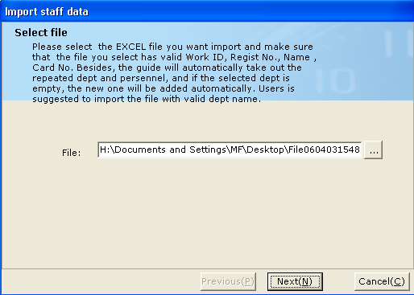
Click “NEXT” button to access the window to select corresponding field of importing personnel data. As shown in the following figure:
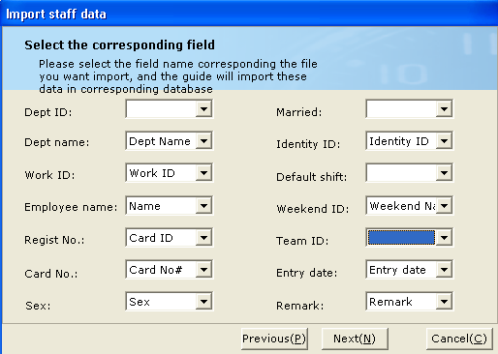
The terms with * must be filled. Then click “next” to finish.
★ Notes:
1, If the equipment type is fingerprint, the personnel’s “registration number” must be the same with the number in the fingerprint. Otherwise the time attendance data will be not exactly.
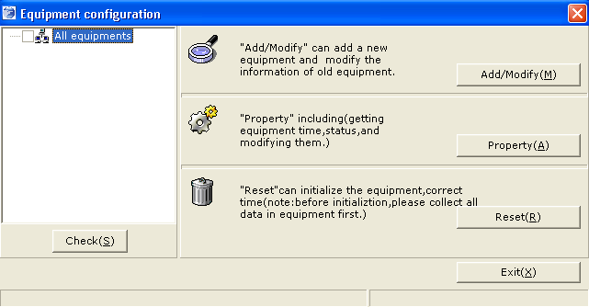
2, For the IT-2100 user, you should first collect data before registering job leave, or data will be lost. It is unnecessary to other users. After the leave registration, you must go to the window of personnel registration to do the logout operation to the job leaver employee, or the information and the clock in/out record of the job leaver is also exist in the terminal.
3, If the personnel data cannot import successfully, you can make the importing EXCEL file in an open mode, and then import again.
5.2 Terminal management
5.2.1 Equipment configure
Equipment configure is used to adding or modification equipment, setting equipment property, initializing equipment etc. Select system menu “equipment management—equipment configure” to access the window of equipment configure. As shown in the following figure.
5.2.1.1 Add or modify equipment
Click “add/modify” button, the window of add/ modify equipment will display, select communication way (232/485 communication or TCP/IP communication), input the range of searching terminal, then select the using communication port (as shown in the following figure), then click “next” to search. After the search is successful then click “finish”
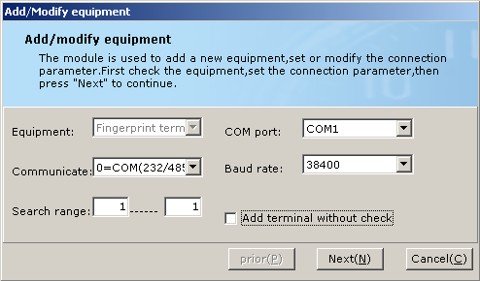
1） 232/485 communication figure, different equipment has different baud rate. The default is used normally.
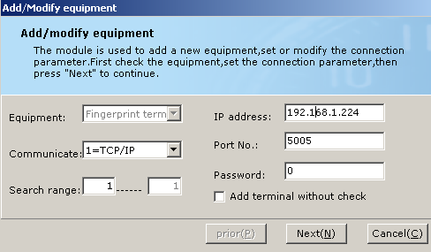
2）TCP/IP communication figure, the fingerprint TCP/IP is 5005.
★ Notes:
1, Make sure the equipment has been connected with computer and can communicate with computer before search. Otherwise there might be some error after a long time searching.
5.2.1.2 Property setting
Equipment property setting is used for changing equipment number and time, setting the time interval of clock, main card, electrical bell, send or clear short message etc. there are some delicate distinctions of the setting program for different equipment. Select system menu “terminal management—equipment configure—property setting” to access the window of property setting.
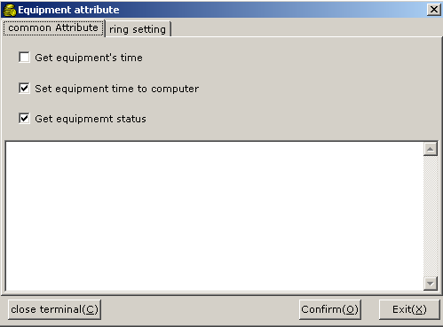
From the normal property, user can obtain the terminal time; synchronous the time both of the terminal and computer; get the system information of the time record terminal.
The electric bell setting: users can set the time and times of the terminal bell, for example,

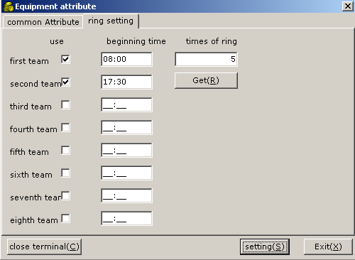
After setting time, click “setting” and a window will exist to show the setting success.

5.2.1.3 User list reading
It designed for read the registered persons information of the terminal. When users need get these information from the terminal, click “read users list”, the obtained number will exist and show as the list in the window , at the time , the registered persons information can be printed and educed.
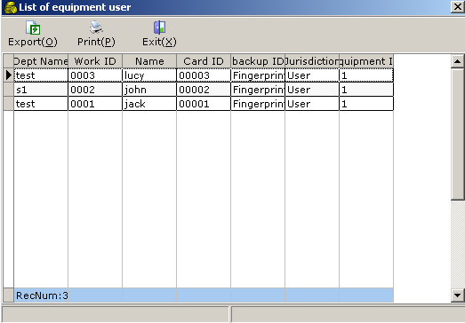

5.2.1.4 Manager authority canceling
It designed for canceling the manager authority of the terminal, click “ Manager authority canceling” and a window will exist, click “yes” and the manager in the terminal will be canceled.

5.2.1.5 Fingerprint and record canceling
It used for canceling the registered fingerprint and stored “in and out”record.Click fingerprint and record canceling and the check window will exist, inputting the user’s name and password. After pass check a window will exist, click “yes” and the fingerprint and record in the terminal will be canceled.

★ Notes:
1, Operation should be done on the condition that its online state. If some
equipment is not online, it will affect the processing speed. Sometimes the system will prompt for “reading the data overtime”.
2, Firstly you should collect data before system initialization, or data will be lost.
3, It is recommended to verify the equipment time in every one week or one month.
4, For the TCP/IP communication way: the initialization is very slow and must wait a long time. If there is still no response from the system after five minutes ( In fact the hardware has been initialized, but the software has not received the returning value of the hardware system), you have to close the software and login again.
5.2.2 Personnel registration
Personnel registration is meant for registration of personnel information to the time attendance terminal, or deleting/rectifying the registered personnel information.
In this system, you can check everyone’s registered permission and get all personnel’s information in the time attendance terminal and save to database. Select system menu “terminal management—>personnel register” to access the window of personnel registration. About the detailed operation ways please refer to the latter appendix or online help.

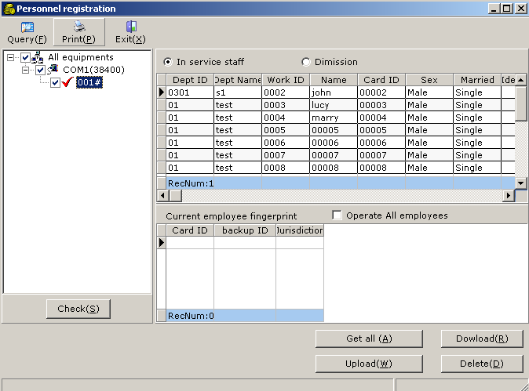

Get all: To obtain all the registered persons information of the terminal and store them in the database. Click this button, it shows the software is getting the information. After the obtaining,a window will exist to show the success number and the failure number.
Download: Singly obtain the registered information of the terminal, this function only effectives when the persons information is exist in the database of management software. Click the record of needed fingerprint then click “Download”and the fingerprint will be stored in the database from the terminal.
Upload: Inputting fingerprint and name into the terminal,both singly and wholely.When need input the whole person’s make a tick in the pane of the picture.
Delete: Delete the fingerprint in the terminal both singly and wholely.

★Notes：
- For the TCP/IP communication way: largely delete the persons, please do not choose operating to all persons for it will be very slow and high failure ,the best way is to choose part of persons to operate.
2. For the TCP/IP communication way: when getting the registered blank, if the progress bar is stopped at one position, close the software and retry.
5.2.3 Data gathering
When you gathering the data of the time attendance terminal, first select the gathering equipment number on the left equipment item, then select “gathering new data” button, click “gathering” to finish.
“Gathering all data”: If the new records in the time attendance terminal have been gathered, for certain reasons like when the user reinstall the system but doesn’t backup the database, if the data in time attendance terminal was not cleared, you should first reinstall the time attendance software, then input the personnel information (fingerprint terminal can obtain the personnel information through getting from the time attendance terminal, then amend in personnel entry), then gather the records again which have been gathered. When you gathering, select the equipment number, then click “gather” to finish.
It used for gathering the record data of the time attendance terminal, input these gathered text files into the software and download the record data stored in U disk into the software. Choose menu “terminal management->data gathering” enter the data gathering window,As the following picture:
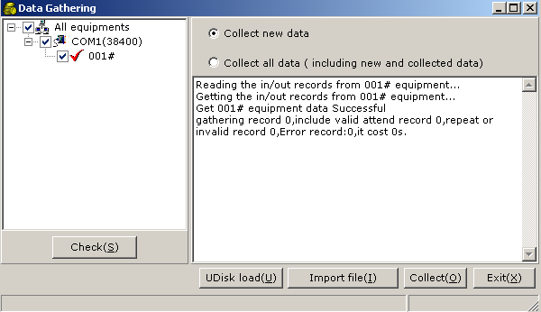
5.2.3.1 Import of the clock in/out file:
The DATA file will create a clock in/out file named with the current date and extend name “cm” automatically after the data gathering. It saves the current time attendance record, but you can import this file into database if the time attendance records in the software were deleted carelessly. Click “clock in/out file import” button and then input your password into the verifying window, then input the file in the optioning window.
5.2.3.2 Download by U disk
After using U disk to download the data from time attendance terminal, You should insert the disk into computer, open the data gathering window, click “download by U disk” button, the software will searching out the files in U disk automatically, select the import files.
(Note: this function is only applied to the time attendance terminal which has U disk download function.
- Note:
- Invalid data means the repeated records or already existed in the database or with an incorrect form (this reason is nearly impossible).
1 The invalid data prompted after data gathering, is used to judge the already existent records in the database or incorrect data in format (you may check the corresponding error record according to the prompt). In general, in order to increase the efficiency of data gathering, please set the scope for the gathering first.
2. After the system is damaged, you may restore the clock in/out data. Find the DATA directory in the installation path, and you may see all the files gathered in the past. You may "Import from file" directly after inputting the personnel data.
5.3 Time attendance management
5.3.1 Time attendance system setting
It is used to set the computing rules for attendance system setting: working shift, overdue, early leave, working overtime, absent and leave of absent. Choose the menu: “time attendance management → time attendance system setting” and enter into time attendance system window, setting all the parameter and click “confirm” to save it.
1. Working shift setting
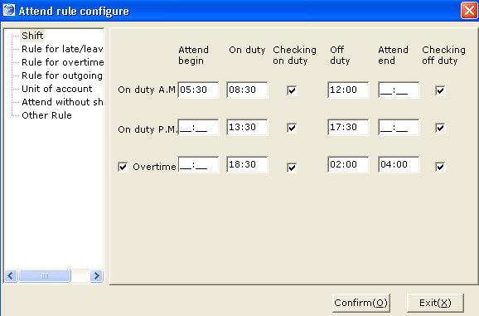

Working shift page is used for setting the signing in and out time for the employee. You can set one or two attendance class and one optional overtime working period. If there is only one working shift, you can only set the time for signing time on the morning and keep the system empty on the afternoon, do not tick “overtime working” option.
It would be the overtime working time if you tick the “overtime working” option.
Clock in time: the original clock time before working time which would not be calculated if overdue, you can option to not set.
Clcok out time: the clock time between off-work time and clock time which would not be calculated if overdue, you can option to not set.

2. Late attendance and early leaving setting
This function is meant for setting the regulation of late attendance and early leaving, the interface is shown as following, you can understand the setting advice by the wordily description, pay attention to the following illuminations:
Whether the late attendance and early leaving should be calculated as attendance: if you choose “yes”, they would be calculated as attendance time and as absence time if you tick “no”
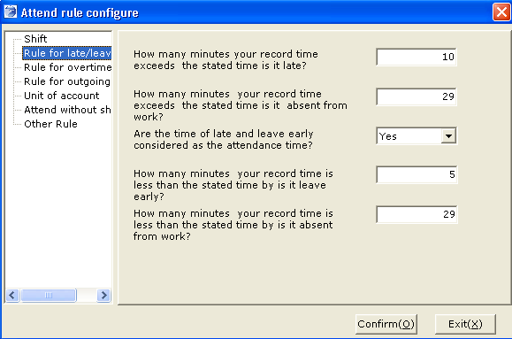
3 .Overtime regulation
Overtime working will be effective if it is longer than certain minutes: it means the system would only calculate the overtime working attendance if it is longer than the period. If you set 29 minutes, the system would not calculate the overtime working attendance for the employee who did 28 minutes.
The condition for the daily overtime working: there are two option: “Clock in/out as well as Register” means the employee must Register on a special attendance book and with the record of signing in/out at the same time; “clock in/out for overtime” is used for the system which will calculate the overtime attendance only if there are signing in/out record.
The condition for the overtime on holiday or festival: “Clock in/out as well as Register” means the employee must register on a special attendance book with explanation on holiday or festival and with the record of signing in/out at the same time; “clock in/out for overtime” is used for the system which will calculate the overtime attendance only if there are signing in/out record on the holiday or festival.
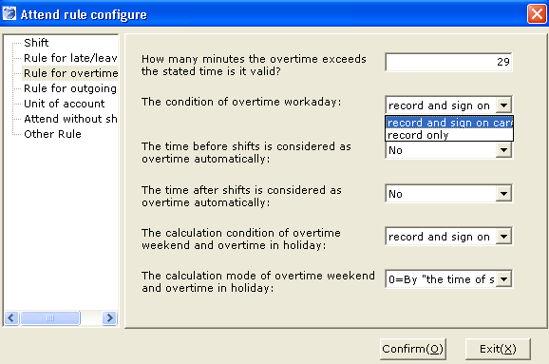
The calculation method for overtime on holiday or festival: “calculated by the working shift” means system will calculate the overtime attendance by the setting of the working shift on holiday or festival; “calculated by signing in/out” means calculate the overtime attendance by the record of signing in/out.
Calculated as overtime for the advanced signing in: if the employee signs in before the setting time, this period would be calculated as overtime, if you choose “yes”, system will calculated automatically and ignore if choose “no”. For example: the setting attendance time is 8:00, if the employee signs in at 7:00, system will record it as 1 hour overtime when you choose “yes” and ignore it if choose “no”
Calculated as overtime for the postponed signing out: if the employee signs out after the setting time, this period would be calculated as overtime: if you choose “yes”, system will calculated automatically and ignore it if choose “no”. It is the same as calculated as overtime for the advanced signing in.

4. Regulation for Egression
Egression will be effective if the out time is longer than certain minutes: egression will be effective if the out time is longer than the setting period.
Absence will be effective if the out time is longer than certain minutes: the out time will be calculated as absence if it is longer than the setting period and egression if shorter than it.
Whether the out time should be calculated as attendance: the out time would not be deducted in the attendance if tick yes and would be deducted if choose “no”.
The picture is as following:
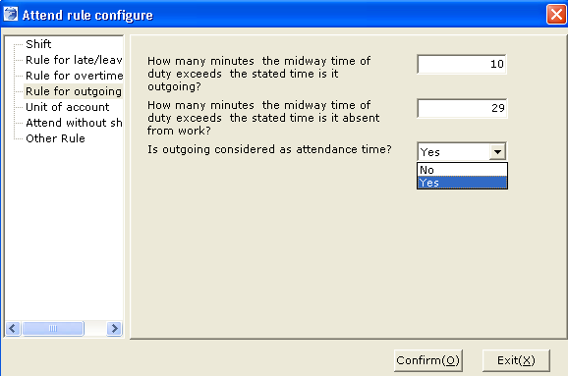

5. Attendance calculation unit
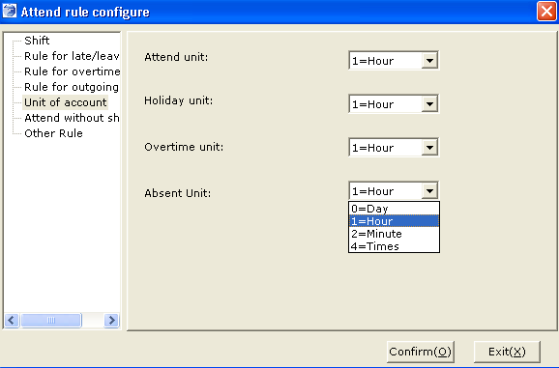
Setting the units that used in attendance calculation: there are four options: day, hour, minutes, times, you can select anyone you want.
6. Unfixed working shift
This function is used for the attendance setting of the unfixed working shift and calculated according to the record of signing in/out. System will note it as attendance if the period between signing in and out is longer than the setting time and absence if it is shorter than that. And then, system can also judge overtime and how long according to the abundance as well as the attendance setting.
This attendance method ignores late attendance an early leaving.
Setting significance:
System will calculate the period as overtime if it is longer than certain minutes: it is used by comparing the attendance time and the setting time of “the certain time which can be calculated as one day attendance”, if the former one is longer than the later, the abundance would be noted as overtime. For example: “the certain time which can be calculated as one day attendance” is set as 480 minutes meantime “the certain time which can be calculated as overtime” is 30, one employee who works 511 minutes one day can get 31 minutes overtime attendance.
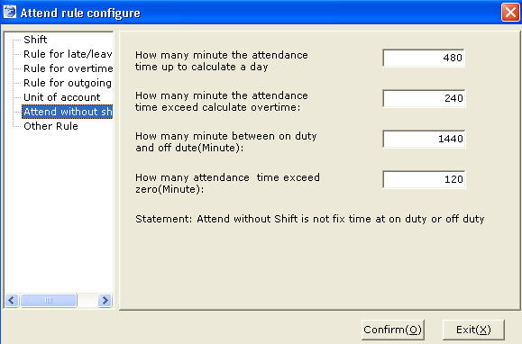
The longest period between signing in and out: the maximum record between signing in and out is 1440 minutes (24 hours), the attendance time for the unfixed working shift can not exceed 24 hours.
The longest period cover 0:00 am: the employee signs in before 0:00am and signs out after it. If you set it as 120 minutes, the employee should sign out before 02:00am.
7. Other regulation:
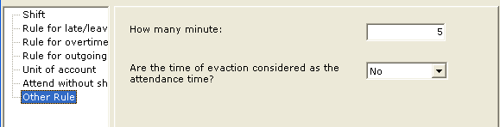
It will be noted as one time if repeating signing within a certain period: system will ignore the repeated signing in a short time when calculate the attendance time. If you set it as 5 minutes, the system only save the first record in 5 minutes; whether the business trip should be calculated as attendance: system would not deduct the time on business trip if tick “yes” and would deduct when choose “no”
- Note:
- You can only get the proper result when you have adjusted the attendance data arrangement if there are any changes of the attendance setting.
5.3.2 Editing attendance time
This function is used to regist the attendance time when the worker forgets to clock in/out.Choose the menu “attendance management →Editing attendance time” and enter to the window, illustrated as below:
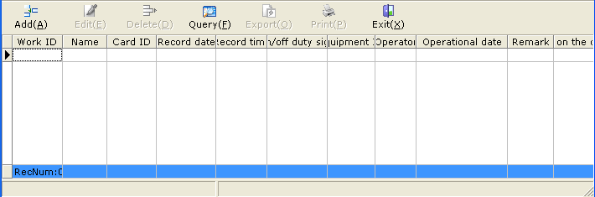
Click “add” button, the window of clock in/out information will appear as below:
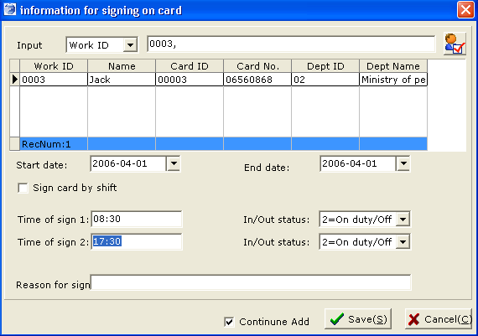
Click the “little head” and choose the name of employee (you can also input the working number or name directly) and then choose the signing in/out time, the action can be finished by inputting the signing time and clicking “save”. The signing time can be the actual time or the setting time.
1. Delete/edit attendance record
It needs to query before delete or edit attendance records
Enter the window of clock in/out registration window and click “query”, then input the query condition, you can leave the unnecessary option empty. You can query all the signing record if choose “clock in/out Registration” in “signing mode” and you can only get the original clock in/out record if tick “clock in/out in”, pictures shown as below:
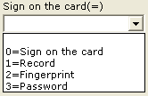
system will default all the manual signing and clock in/out if you do not select.
Query the signing record of one employee: refer to the following picture:
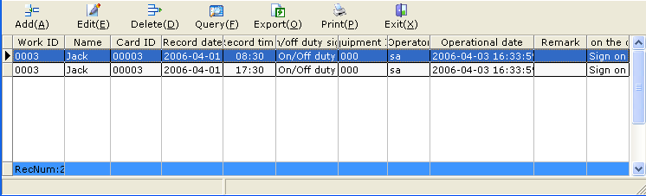
Delete record: pitch on the record that you want to remove and click “delete”.
Edit record: pitch on the record that you want to adjust and click “edit” ,then click “save” after correction.
★ Note: you can delete and edit both the clock in/out and Registration record by software.
5.3.3 Special time attendance Registration
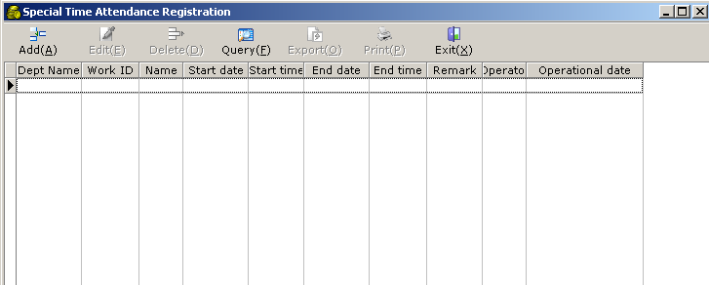
Choose the employee, attendance date and attendance mode(overtime work, official holiday, asking for leave, on business or egression), attendance project (there are different attendance project for each attendance mode), and then input the signing in/out time, afterwards the work can be finished by clicking “save” button.
The signing time can input according to either actual time or the working shift setting. You can just choose the corresponding working shift if choose this mode.
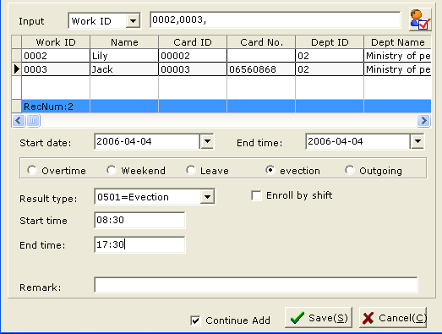
1. Delete/edit special attendance record.
Click “query” to open the query page in special attendance Registration window, input query condition and leave the unnecessary condition empty. Showed as below:
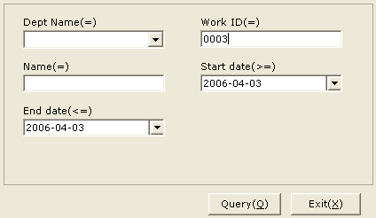
And then click “query” button and you can get the proper record. Refer to the following:
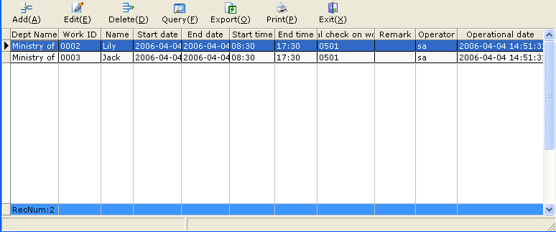
Pitch on the special record that you want to remove and click “delete”
Pitch on the special record that you want to adjust and begin the edition after click “edit”, remember to save it after correction.
5.3.4 Time attendance processing
Time attendance processing means working out the time attendance result of each person according to time attendance system, work shift, holiday and official holiday set in the system, and the time attendance setting, clock in/out and special time attendance registration of each person: The data includes attendance, overtime, official holiday, late attendance, early leave, absence, leave of absence and so on. After the time attendance data processing, you may see the time attendance result report forms. Select system menu “time attendance management →attendance processing” and enter into the designated window.
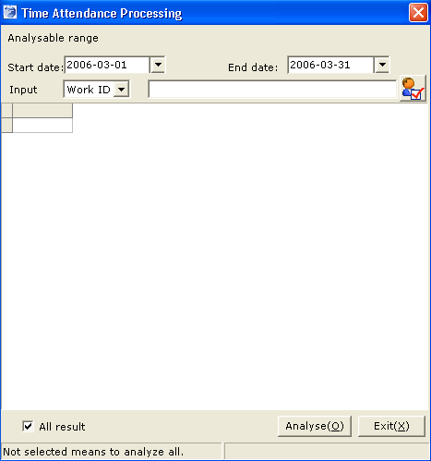
Choose the special date, employee for attendance data processing or the system will default the entire available person. Pitch on “screen all the processing result” and click “data processing” to begin the attendance data processing.
- Note:
- The reason for failed processing result of some employees: the employee do not default the working shift; whose register time is later than the date of attendance data processing.

5.4 Access control management
5.4.1 Equipment location setting
This function is used for mark the location of the attendance equipment, Select system menu: “access control management → equipment location management” and enter the specify window: illustration as following:
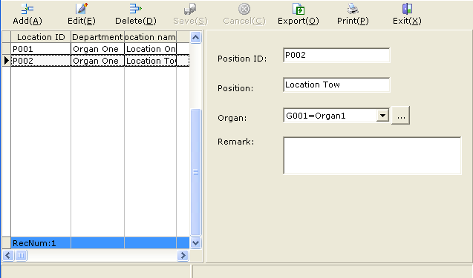
Click “add” button to add the location of the equipment, and then click the button in the status of adding or editing can fulfill the action of adding or editing the subsidiary setup.
5.4.2 Clock in/out detail query.
This function is meant for query the record of injunction signing record, choose system menu: “Access control management→ Clock in/out detail query.”
Input the corresponding condition into the special window and leave the unnecessary ones empty, then click the “query” button, the result will come out as below:
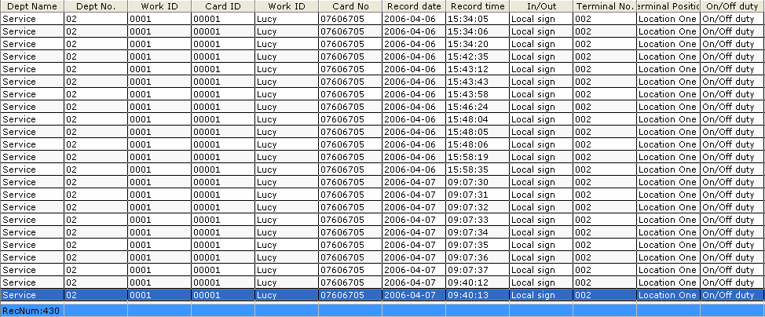
You can print the report forms by click “print” or “export”
5.5 report forms printing
5.5.1 Clock in/out list
This table is used for collecting the original data from the attendance equipment with a single line for each record. Select system menu “report forms printing→ clock in/out detailed list” and enter into the designated query window as following:
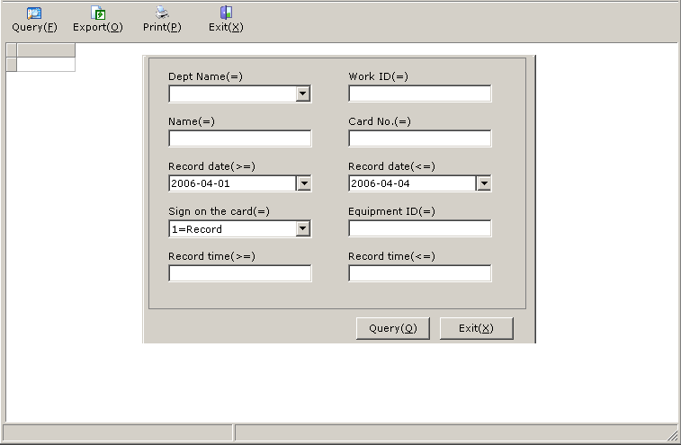
Input the corresponding condition into the special window and leave the unnecessary ones empty, then click the “query” button, the result will come out as below:
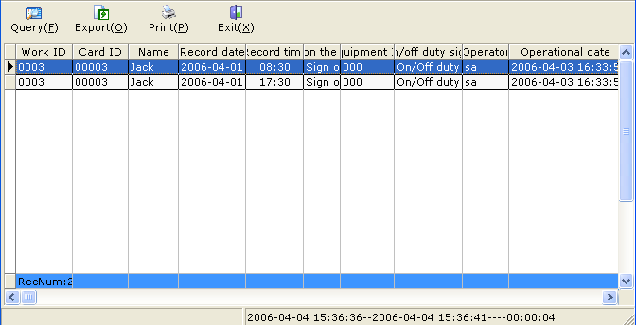
You can print the report forms by click “print” or “export”
5.5.2 Daily Clock in/out list
This table is designed to query the original data that collected from the attendance equipment with a single line for each record. Select system menu “report forms printing → Daily clock in/out list” .
Input the corresponding condition into the special window and leave the unnecessary ones empty, then click the “query” button, the result will come out as below:
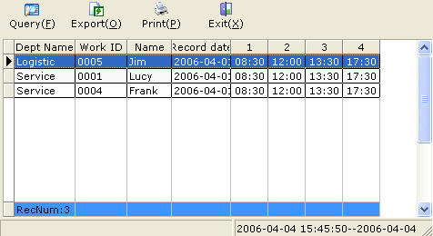
You can print the report forms by click “print” or “export”
5.5.3 Exceptional Clock in/out list
This function is to query the exceptional clock in/out status, such as late attendance, early leave and absence etc. Select system menu “report forms printing →exceptional clock in/out list” .
Input the corresponding condition into the special window and leave the unnecessary ones empty, then click the “query” button, the result will come out as below:
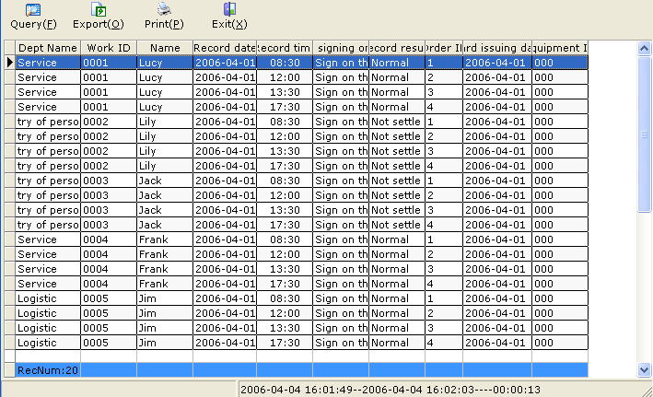
You can print the report forms by click “print” or “export”.
5.5.4 Daily time attendance list
This function is used for querying the attendance detail of each employee with one single line for each attendance record. Choose system menu “report forms printing →Daily time attendance list” and enter the specify query window as following:
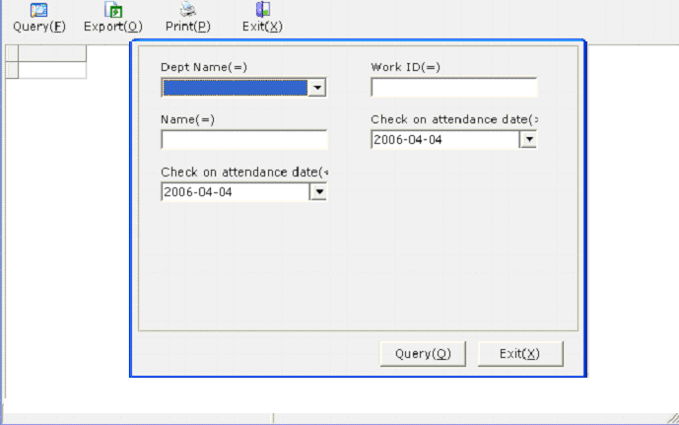
Input the corresponding condition into the special window and leave the unnecessary ones empty, then click the “query” button, the result will come out as below:
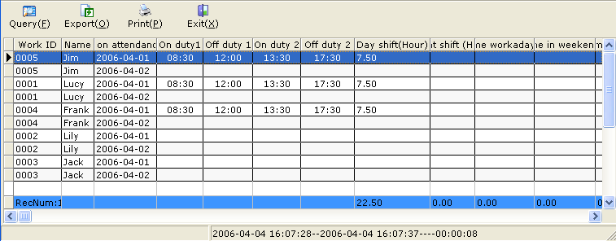
You can print the report forms by click “print” or “export”. The table can be scanned by click “print” and then “confirm”
Attached: sheet setting function
This function is applied for all the query table which means to help the customer to set the format of the sheet freely: such as width, heading, reveal or not, taxis, summation and so on. Detailed operation as following:
- Click the head row of the sheet as below:
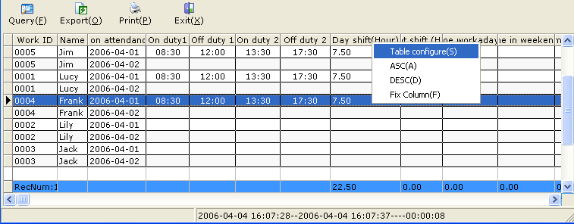
- Sort ascending: the content would be arrayed by sort ascending.
- Sort descending: the content would be arrayed by sort descending.
- Hold Column: holds the column in the left side and the column in the right side will scroll when click the scroll bar plainly.
- Sheet setting: open the setting window to set the attribute of the column: setting the heading, reveal or not, width, adjusting mode, summation (only applied for numeral), average value (only applied for numeral), defaulted column mode. Illustrated as following:
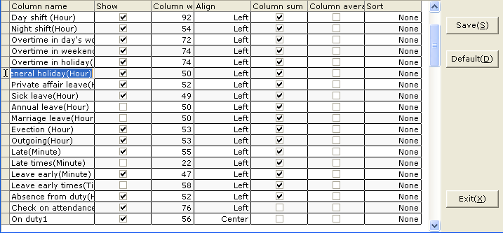
  - The column width showed in the above table is the defaulted value before setting; however, you can adjust it manually and then save them in the setting window, please do not correct it by inputting concrete value to define the column width.
  - Double click the special column that should be adjusted and it will be present as reverse video, then you can edit and save it in the system
  - You can also tick the significant column which should display and ignore the unnecessary one and save it.
★ Note:
This function is applicable to all the tables in system, such as: Personnel entry, clock in/out registration, special attendance registration, daily time attendance list, monthly attendance statistics, original clock in/out list, daily clock in/out list and exceptional clock in/out list.
5.5.5 monthly attendance statistics
This function is designed for enquiry the monthly attendance record detail for every employee showed with a single row for each employee. Choose system menu: “report forms printing →monthly attendance statistics” and enter into the designated enquiry window as following:
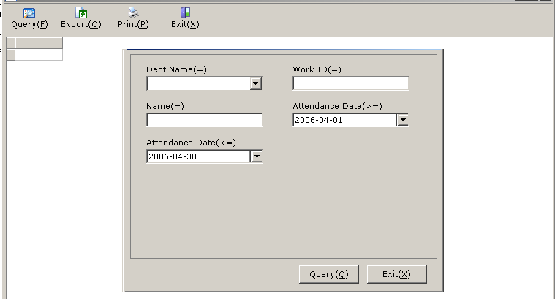
Input the corresponding condition into the special window and leave the unnecessary ones empty, then click the “query” button, the result will come out as below:
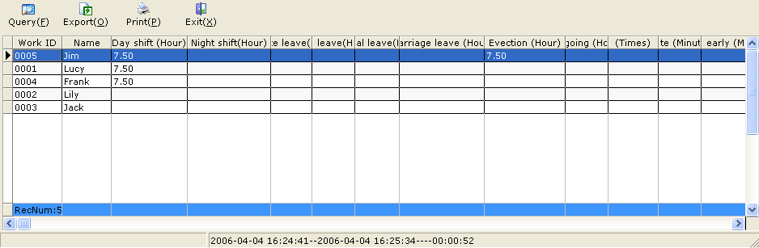
You can print the report forms by click “print” or “export”. The information showed in the table can be modified according to the operation instructions of sheet setting.

5.5.6 Daily attendance symbolic list.
This function is used for enquiring the daily attendance summary and displaying the status with symbol. Choose system menu: “report forms printing → daily attendance symbolic list” and enter the specify enquiry window as following: 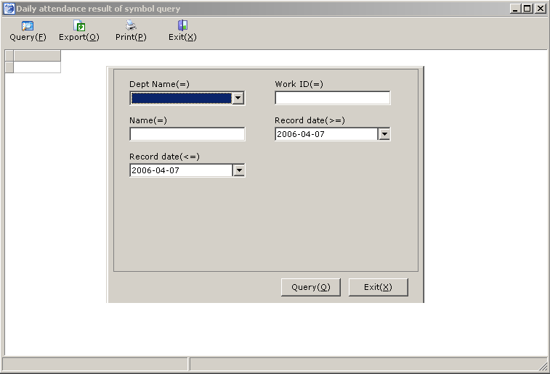
Input the corresponding condition into the special window and leave the unnecessary ones empty, then click the “query” button, the result will come out as below:
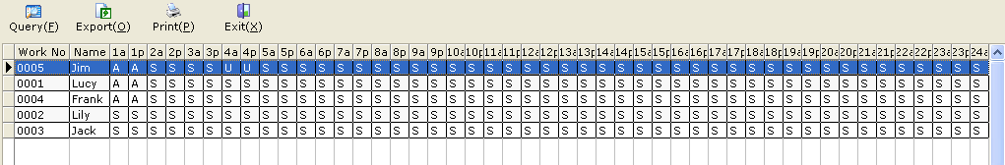
You can print the report forms by click “print” or “export”. The information showed in the table can be modified according to the operation instructions of sheet setting.
5.6 System maintenance
5.6.1 Changing your password
The username for initial system login is the account of system administrator: sa, and password is blank. You are suggested to change your password after the initial login.
Click the menu “System maintenance -> Change password”, input a new password and confirm the new password (password can be set as 1-10 numbers or letters), as shown in the following figure. Then click OK to confirm.
It used for resetting the password of now operator and the old password can not be used anymore. Click the menu “System maintenance -> Change password” to enter the window of changing the password.
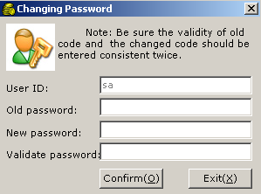
Input old password, new password and click “Confirm”.

5.6.2 System permission management
This function is used for adding an operator, setting the operator's password and permission Click the menu "System maintenance-> management of operater" to enter the window for system permission management, as shown in the following figure:
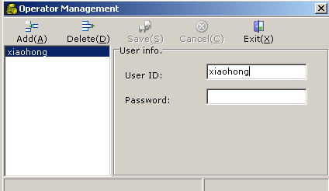
If you want to add an operator, click the ‘Add’ button, input the operator's name and password and save it.
When you wish to delete the permission, choose the destination operator on the left then click the ‘Delete’ button.
5.6.3Database Maintainence
5.6.3.1 Backup Database
It means to backup all the data in SQL Server of this system to a file, once the computer suffers ruin,it can restore the data. Click the menu "System maintenance-> Database maintenance" to enter the window. As the following picture.

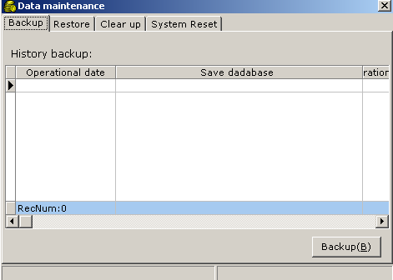
Click button, inputting the check number then choose the method of files saving.
5.6.3.2 Data restore
It means to restore the database from the old backup files into now system and restored database is the same situation with the old one. Click the menu "System maintenance-> Database maintenance " from second tab to enter database restore, as shown in the following figure:

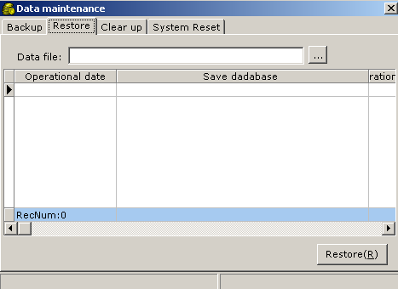

Click to choose the data files needed to restore,then click
and input checking password. After the database successfully restore, the software will auto exit.

5.6.3.3 Data cleaning
cleaning is designed to clear the record of some old data. By clearing the log of the database, you may reduce the size of the database files. Click the menu "System maintenance-> Database maintenance " from third tab to enter the window for data cleaning, as shown in the following figure:

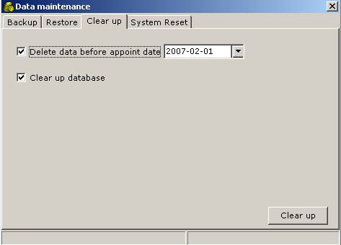

5.6.3.4 System initialization
System initialization is designed to clear all the data, and return to the initial installation state, Click "System maintenance-> System initialization " to enter the initialization , showing as the following picture:
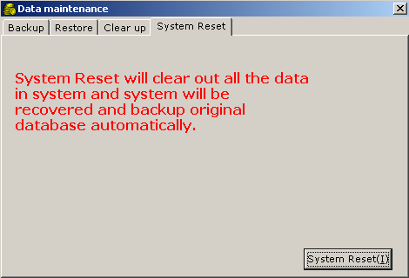
Click ,input checking password. At the time of initialization, system will auto backup current database and save it after choosing backup path.
Note:
1. The system initialization will clear all the data, so, you must make data backup before initialization.When you make data backup, the default path is the BackUp directory under the software installation directory. The default filename is Data+ current date and time. You may choose the path and filename for data backup according to your needs.
2. Only backup database in the computer which has database. For the backup files only stored in this computer.
3. If users want to restore the system to the old state for the mistake operation, they can choose data files in the corresponding restored record.
5.6.4 Operation log query
It is designed for querying important operation records and operation results of the system. For example, all such operations as system login database backup, system initialization and so on, will be recorded in the operation log.
Click the menu "System maintenance-> Operation log query" to enter the window for operation log query, as shown in the following figure:
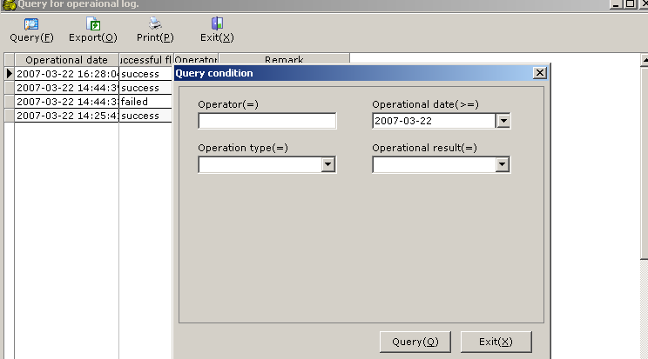
Input the necessary conditions in the query window and click “check”.

Chapter Six FAQs

Ⅰ. Question: I failed in my installation of MSDE, and there was such a prompt in the process of installation: The Instance name specified is invalid, Please tell me how to solve this problem.
Answer:
1. Enter the "Add or remove programs" in the control panel to delete the Microsoft SQL Server Desktop Engine.
2. Reinstall A0 software and MSDE, and you must restart you computer after the installation.

★ You should pay attention to the following issues in installation of MSDE:
1. Software requirement and system requirement
MSDE 2000 requires the installation of Microsoft Internet Explorer 5.0 or higher. The minimum installation is enough, and the Internet Explorer need not be the default browser.
2. Except for Windows 98 and Windows Millennium Edition, the file and printer sharing function should be started, so as to run Desktop Engine Setup.exe. To verify this point, please carry out the following operation:
In "Control panel", double click "Network connection". Click "Property" in the option tab "Adapter and binding", confirm that you have chosen "File and printer sharing for Microsoft Network".
3. If any of the following security policies is set as "Disable installation", the installation of MSDE 2000 Release A will fail:
1> Local security policy of Windows XP, "EDevice: Installation operation of unsigned driver".
2> Local security policy of Windows 2000, "Device: Installation operation of unsigned non-driver".
If you have set "Disable installation", you will have to change the setting into "Default continuation" before installation of MSDE 2000 Release A. If necessary, you may restore the policy into the former setting after the installation. ”Disable installation" is not the default setting of these security policies. To set these policies, please carry out the following operation:
1> In "Control panel", double click "Administation tools".
2> Double click "Local security policy" to open "Local policy".
3> Select "Security options".
4> Ensure the following options in the right window pane are set to "Default continuation" before installation of MSDE 2000 Release A:
In the case of Windows NT and Windows2003: "Device: Installation operation of unsigned driver". In the case of Windows 2000:"Installation operation of unsigned non-driver".
II. Question: How to do when a new employee are enrolled?
Answer:
- Enroll his data into terminal and remember his No
- Input his information in personel entry,keep his No same as terminal
- If you have many employee to enroll,you can enroll them into terminal all at first,then get back fingerprint information from terminal to database,in the end you can modify them in personel entry.

III. Question: How to do when a employee leave the company?
Answer:
1>Firstly, gathering the whole record data then check that all the fixed data have been gathered.
2>Enter the employee enroll to click job leave,adding the employee as the leave person.
3>Enter employee registration to choose equipment and delete the person.
4>Then delete the employee in leave person.
IV. Question: How to delete somebody’s repeat time record?
Answer:
Click the menu "print-> report form center ",select report of attend detail list,then you can query the repeat record,right click on the repeat record,select “delete” to delete it.

V. Question: How to do when I want to see time attendance result of somebody?
Answer:
  - Gather data from terminal
  - Process data of which you want to query attendance(employee must has been assigned work shift)
  - Click the menu "print-> report form center ",select report of daily attend summary table to query

VI. Question: Can the column be hide which I don’t need in the table?
Answer:
Yes.You can hide at will.click the table title,select “Table configure” of the menu, you can configure the table and save it

